Software
# Source: AI Source: Provided by: [Data Path: Persons Table -> ID Column: 1, Name_En Column: Motasem Essam] -> From: [ChatGPT] on [4/22/2026]
Software is a set of programs and instructions that tell a computer what to do.
# Source: Academic source: Provided by: [Data Path: Persons Table -> ID Column: 1, Name_En Column: Motasem Essam] -> From: [Data Path: Sources Table -> ID Column: 162, Content Title Column: Academic Source - Modern academy - 2017-2018 - Intro to Computer Science - System software operating systems and utility programs] -> at: [Document, page: 2, (top, middle), “Image - Tool: [Lightshot Program]”] on [4/22/2026]
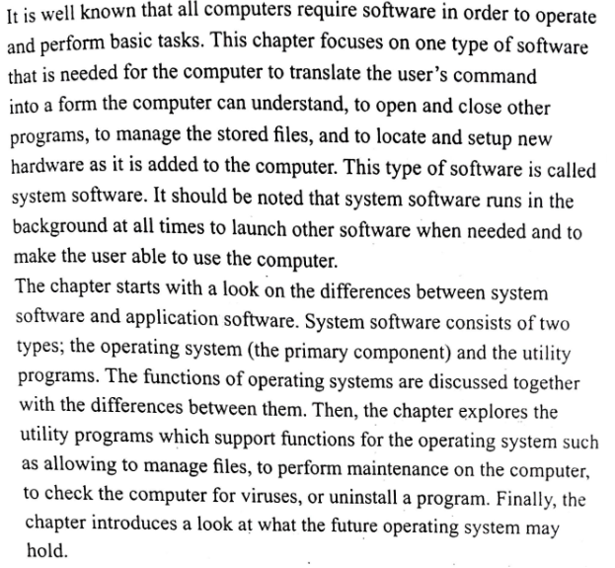

🧠 Simple idea
# Source: AI Source: Provided by: [Data Path: Persons Table -> ID Column: 1, Name_En Column: Motasem Essam] -> From: [ChatGPT] on [4/22/2026]
If hardware is the body, then software is the brain that controls it.

⚙️ What software does
# Source: AI Source: Provided by: [Data Path: Persons Table -> ID Column: 1, Name_En Column: Motasem Essam] -> From: [ChatGPT] on [4/22/2026]
- Controls hardware
- Processes data
- Performs tasks (like calculations, browsing, gaming)

🌍 Examples of software
# Source: AI Source: Provided by: [Data Path: Persons Table -> ID Column: 1, Name_En Column: Motasem Essam] -> From: [ChatGPT] on [4/22/2026]
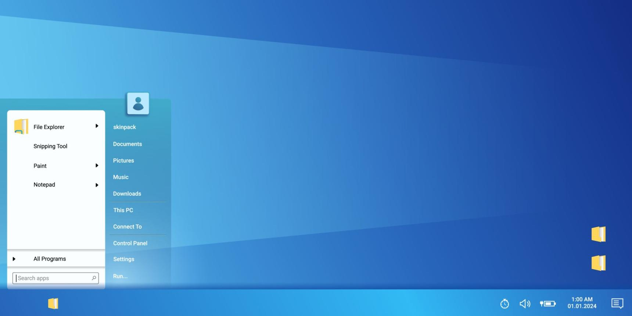

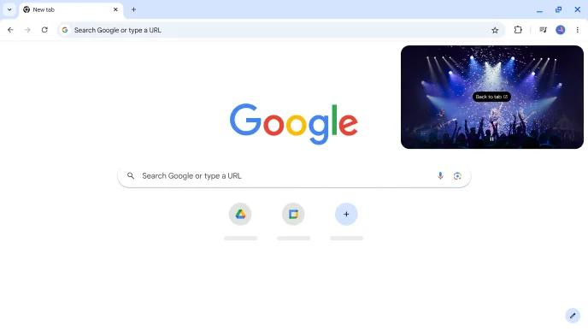
- Operating systems (Windows, Linux, Android)
- Applications (Word, Chrome, games)
- Utility programs (antivirus, file managers)

🔹 Types of software
# Source: Academic source: Provided by: [Data Path: Persons Table -> ID Column: 1, Name_En Column: Motasem Essam] -> From: [Data Path: Sources Table -> ID Column: 162, Content Title Column: Academic Source - Modern academy - 2017-2018 - Intro to Computer Science - System software operating systems and utility programs] -> at: [Document, page: 3, (top, middle, bottom), “Image - Tool: [Lightshot Program]”] on [4/22/2026]
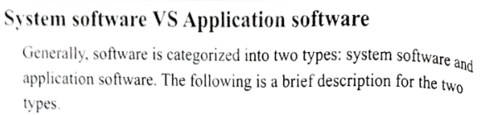
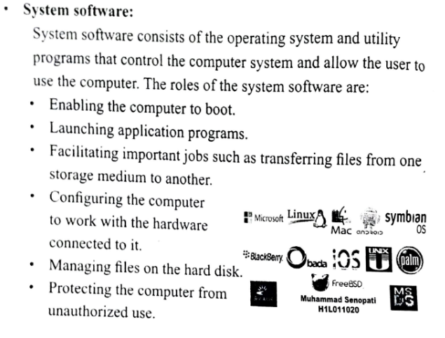
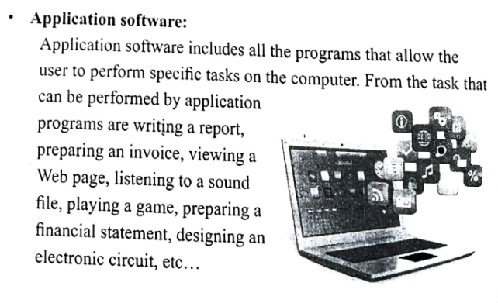

# Source: AI Source: Provided by: [Data Path: Persons Table -> ID Column: 1, Name_En Column: Motasem Essam] -> From: [ChatGPT] on [4/22/2026]
1. System Software
- Controls and manages hardware
- Example: Operating system
2. Application Software
- Helps users perform tasks
- Example: MS Word, browser, games

🔄 Hardware vs Software
# Source: AI Source: Provided by: [Data Path: Persons Table -> ID Column: 1, Name_En Column: Motasem Essam] -> From: [ChatGPT] on [4/22/2026]
- Hardware = physical parts
- Software = instructions/programs
👉 Both must work together

🧾 One-line definition
# Source: AI Source: Provided by: [Data Path: Persons Table -> ID Column: 1, Name_En Column: Motasem Essam] -> From: [ChatGPT] on [4/22/2026]
Software is the collection of programs that instruct a computer to perform tasks.

